Processes of Memory - Storage
# Source: AI Source: Provided by: [Data Path: Persons Table -> ID Column: 1, Name_En Column: Motasem Essam] -> From: [ChatGPT] on [5/1/2026]
Storage (keeping information over time)
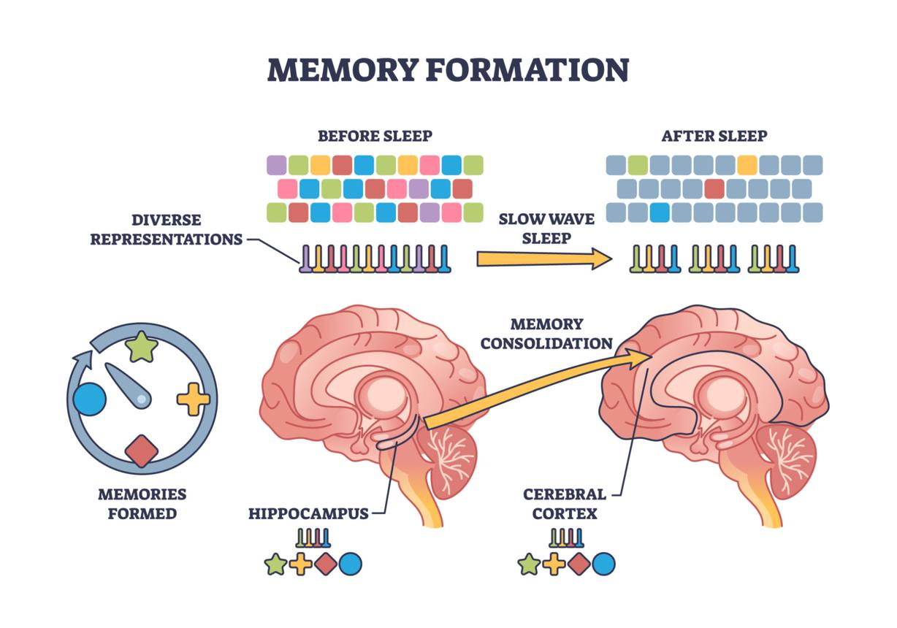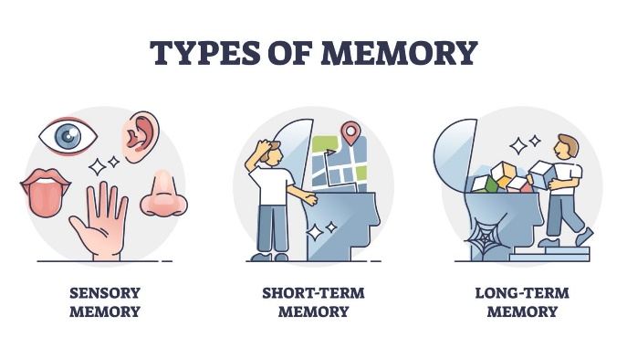
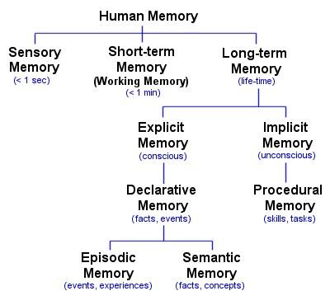
Storage is the stage of memory where encoded information is maintained over time. It’s not a single “place” in the brain—it’s a dynamic system involving multiple memory stores and brain regions.

Main Types of Memory Storage

1. Sensory Memory
# Source: AI Source: Provided by: [Data Path: Persons Table -> ID Column: 1, Name_En Column: Motasem Essam] -> From: [ChatGPT] on [5/1/2026]
- Duration: milliseconds to a few seconds
- Stores raw sensory input (visual, auditory, etc.)
- Example: briefly “seeing” an image after it disappears

2. Short-Term / Working Memory
# Source: AI Source: Provided by: [Data Path: Persons Table -> ID Column: 1, Name_En Column: Motasem Essam] -> From: [ChatGPT] on [5/1/2026]
- Duration: ~15–30 seconds (without rehearsal)
- Capacity: about 7 ± 2 items (can be improved with chunking)
- Used for active thinking (e.g., solving a math problem)
Psychologist George A. Miller is known for this capacity estimate.

3. Long-Term Memory
# Source: AI Source: Provided by: [Data Path: Persons Table -> ID Column: 1, Name_En Column: Motasem Essam] -> From: [ChatGPT] on [5/1/2026]
- Duration: potentially lifetime
- Capacity: virtually unlimited
Types include:
- Explicit (declarative)
  - Facts (semantic)
  - Events (episodic)
- Implicit (non-declarative)
  - Skills and habits (procedural)

How Storage Works (Consolidation)
# Source: AI Source: Provided by: [Data Path: Persons Table -> ID Column: 1, Name_En Column: Motasem Essam] -> From: [ChatGPT] on [5/1/2026]
Before information becomes long-term, it goes through consolidation—a process of stabilizing and strengthening memory traces.
- The hippocampus plays a key role in forming new memories
- Over time, memories become more distributed across the brain (especially the cortex)
- Sleep significantly improves consolidation

Factors That Affect Storage
# Source: AI Source: Provided by: [Data Path: Persons Table -> ID Column: 1, Name_En Column: Motasem Essam] -> From: [ChatGPT] on [5/1/2026]
- Rehearsal
  - Maintenance: simple repetition
  - Elaborative: linking meaning (stronger)
- Organization
  - Structured information is stored more effectively
- Emotion
  - Emotionally charged memories tend to be stronger
- Interference
  - New or old information can disrupt storage
  - Proactive interference: old info affects new learning
  - Retroactive interference: new info affects old memories

Simple Example
# Source: AI Source: Provided by: [Data Path: Persons Table -> ID Column: 1, Name_En Column: Motasem Essam] -> From: [ChatGPT] on [5/1/2026]
You study for an exam:
- If you just repeat facts → weak storage
- If you connect ideas, organize notes, and sleep well → strong long-term storage

Big Picture
# Source: AI Source: Provided by: [Data Path: Persons Table -> ID Column: 1, Name_En Column: Motasem Essam] -> From: [ChatGPT] on [5/1/2026]
Storage is what allows memory to persist beyond the present moment.
Without effective storage, even well-encoded information fades quickly.

